**Week 7 Solutions**

**React**

**13. ReactJS-HOL** .

Estimated time to complete this lab: **60 minutes.**

Create a React App named “bloggerapp” in with 3 components.

1. Book Details
2. Blog Details
3. Course Details

Implement this with as many ways possible of Conditional RenderingThe code and the folder structure is attached in the **Week 7/** **bloggerapp** folder

**Output :-**

**Chrome –** [**http://localhost:3000/**](http://localhost:3000/)

**The Page looks like this :-**

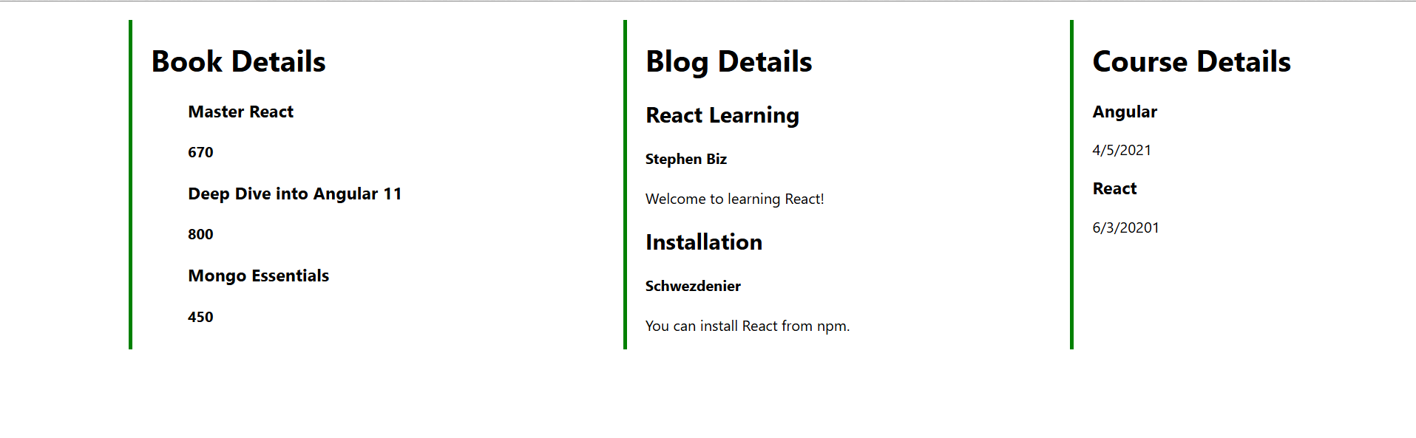

**The hands on file and folder is attached along with it**